1. **Title of Project: Aadhar based disaster relief management system.**
2. **Name of college: YSPM’s Yashoda Technical Campus, Satara.**
3. **Name of Department:** Computer Science And Engineering

1. **Name of students:**
   * 1. Ganesh Balu Kakade.
     2. Janhavi Rajkumar Patil.
     3. Prerna Pravin Jadhav.
     4. Riya Anand Desai.
     5. Utkarsha Sunil Velhal.

1. **Name of guide:** Dr. S.V. Balshetwar.
2. **Relevance :** An Aadhar-Based Disaster Relief Management System is crucial for effective disaster management in India, as it ensures aid reaches verified and eligible beneficiaries, reducing fraud and resource wastage. By streamlining relief distribution through Aadhar-linked identification, this system allows for quick, efficient, and targeted aid, improving transparency and accountability. It minimizes duplication, tracks resources in real-time, and offers valuable data for future disaster planning. Ultimately, it supports a fair, timely, and needs-based response, enhancing the overall resilience and recovery of affected communities.

1. **Literature Review:**

1) This paper highlights Aadhar, India’s biometric-based identification system, has significantly improved beneficiary verification in various welfare schemes. Authors argue that using Aadhar for disaster relief distribution can ensure resources reach verified, legitimate beneficiaries, reducing duplication and misuse, which are common challenges in large-scale disaster aid distribution.

2) This paper indicates that integrating technology in disaster management, including biometrics and digital identity systems, enhances the speed and efficiency of relief processes. They emphasize that Aadhar’s digital platform can enable real-time authentication, helping authorities rapidly identify and serve affected populations, which is critical in disaster response.

3) This survey shows use of Aadhar in sensitive applications, like disaster relief, raises privacy concerns. They discuss the risks of data breaches and unauthorized access, particularly in high-stress disaster contexts where personal data security may be compromised. Research suggests implementing stringent security protocols to protect beneficiary data and ensure compliance with privacy laws.

4) The integration of Aadhar with disaster relief efforts can improve transparency and accountability. According to authors, Aadhar-linked systems enable real-time tracking of resources and beneficiaries, thus ensuring that aid reaches intended recipients without leakage or diversion, a persistent issue in traditional distribution models.

5) Studies compare Aadhar-based systems with biometric relief distribution practices in other countries, such as Indonesia and the Philippines. They conclude that such systems improve efficiency and prevent fraud in relief distribution, underscoring Aadhar's potential to streamline similar processes in India by creating an accurate beneficiary database.

1. **Problem identification:**

1. Fraud and Misidentification : Traditional relief distribution methods often suffer from identity fraud, leading to resources being allocated to ineligible individuals. Misidentification can result in vulnerable populations being overlooked during aid distribution.

2. Inefficient Resource Allocation: Delays in identifying beneficiaries and distributing aid can exacerbate the suffering of affected communities. Many existing systems lack real-time data, hindering timely responses.

3. Lack of Coordination: Disparate agencies and organizations often work in silos during disaster response, leading to duplication of efforts or gaps in aid distribution. This lack of coordination can waste resources and diminish the effectiveness of relief efforts.

4. Accessibility Issues: In remote or disaster-affected areas, beneficiaries may have limited access to information about available aid, leading to confusion and unmet needs.

5. Data Privacy Concerns: The collection and storage of personal data raise significant privacy issues, particularly in the context of biometric identification. Concerns over data security and misuse can hinder community trust in relief efforts.

1. **Block Diagram:**

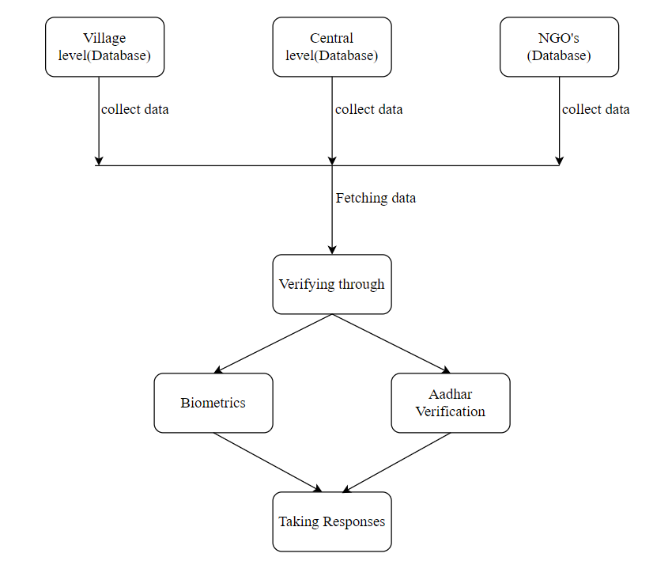

1. **Experimental Setup:**

**Hardware Development Requirement:**

Computer or Cloud Server: To host the central database and application.

Biometric Device or Scanner: For Aadhaar authentication simulation.

Tablets or Smartphones: For agents to access the system on the field.

**Software Development Requirement :**

Database System: MySQL, PostgreSQL, or Firebase for beneficiary and transaction data storage.

Web Server: Apache or Nginx to serve the web application.

Backend Development Framework: Java (Spring Boot), Node.js, or Python (Django/Flask) for core application logic and Aadhaar verification.

Frontend Development Framework: HTML, CSS, JavaScript (React or Angular) for the user interface.

UIDAI Aadhaar Authentication API Sandbox: For simulating Aadhaar verification.

Security Protocols: HTTPS for secure data transmission, and data encryption libraries for sensitive information.

**11.Scope of Project:**

1. Early Warning and Real-Time Monitoring: Predict and monitor disasters using real-time data to provide timely alerts to authorities and the public.

2. Resource and Personnel Management: Efficiently allocate resources and coordinate responders to ensure prompt and organized relief efforts.

3. Communication and Public Alerting: Establish reliable communication channels for responders and send alerts to communities about safety measures and evacuations.

4. Post-Disaster Recovery: Track and manage long-term recovery efforts, including infrastructure rebuilding and rehabilitation for affected populations.

**12.Objective**

1. **Streamlined Identification**: Use Aadhaar for accurate identification of beneficiaries, reducing fraud and ensuring that aid reaches the intended recipients.
2. **Efficient Management**: Facilitate quicker and more organized management of distribution of relief materials and funds.
3. **Real-time Data**: Enable real-time tracking of aid distribution and beneficiary needs through a centralized database.

**13.Proposed work:**

1. Beneficiary Identification: Use Aadhaar for secure and accurate identification of disaster-affected individuals.

2. Centralized Database: Maintain a central record of beneficiaries, resources, and distribution status.

3. Resource Allocation: Allocate and track relief supplies to verified beneficiaries.

4. Efficient Distribution: Automate and streamline aid distribution for faster response.

5. Transparency: Ensure accountability with clear records accessible to authorities.

**14. Motivation for work :**

The motivation behind an Aadhaar-Based Disaster Relief Distribution System is to ensure that aid reaches those who genuinely need it, quickly and efficiently, during critical times of disaster. In many relief efforts, misidentification and duplication lead to delays and misallocation of resources. By leveraging Aadhaar, a unique identity system, this project aims to streamline aid distribution, reduce fraud, and bring transparency and accountability to the relief process. This approach not only speeds up relief operations but also builds trust among beneficiaries and ensures fair, equitable distribution of resources in times of crisis.

**15.Expected Outcome:**

1. Efficient and accurate aid distribution.

2. Reduced fraud.

3. Increased transparency and accountability

4. Improved Disaster Management

1. **Expected Date of Completion:**

1. **Approximate Expenditure:**







**18.References**:

[1)Title:](https://www.researchgate.net/publication/360646224_Fraud_Detection_and_Analysis_for_Insurance_Claim_using_Machine_Learning) *Technology Integration in Disaster Management: Enhancing Efficiency and Response*.

Author-Sharma, A., & Gupta, R. (2020)

2)Title:-Technology Integration in Disaster Management

Author:- Pandey and Chaturvedi.

3)Title:-Data Privacy and Security Concerns

Author:- Ranjan and Bose.

4)Title:- *Biometric Solutions for Aid Verification in Disaster Management*.

Author:- Kumar, S., & Patel, D. (2019).

5)Title:- Comparative analysis with global practices.

Author:- Haque and Tanaka.

**Place: Satara**

**Date:**



| **PRN No.** | **Name of Student** | **Signature** |
| --- | --- | --- |
| 2167571242027 | Ganesh Balu Kakade |  |
| 2167571242040 | Janhavi Rajkumar Patil |  |
| 2167571242032 | Prerna Pravin Jadhav |  |
| 2167571242005 | Riya Anand Desai |  |
| 2167571242013 | Utkarsh Sunil Velhal |  |

**Project Guide HOD**

**Dr. S. V. Balshetwar Dr. S. V. Balshetwar**